**Assignment 2 Template**

**LAST NAME: Lawson**

**FIRST NAME:John**

**USERID: jd2lawso**

**UWaterloo ID:20466075**

**Problem 2: The first three numbers in your Exponential data set are:**

|  |  |  |
| --- | --- | --- |
| **0.1289791** | **0.4941612** | **0.5841653** |

**Theta = 3.788**

**The maximum likelihood of theta is thetahat = 5.076**

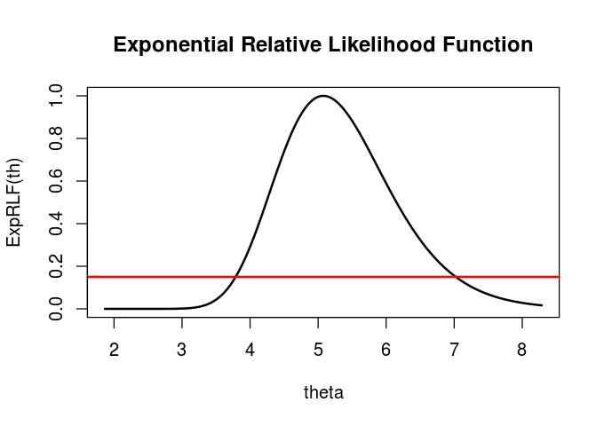

**Based on the graph of the relative likelihood function and the line y = 0.15 the 15% likelihood interval for theta is:**

**3.75-7.0**

**Using the R function uniroot the 15% likelihood interval is:**

**3.787474-7.023735**

**Is theta = 2 a plausible value of theta for your data set? Why?**

**Is theta = 8 a plausible value of theta for your data set? Why?**

**Neither theta = 8 or 2 area plausible values for my dataset, since they both fall well outside of the 15% confidence interval. (and are both thus unlikely estimates for theta, given the values used)**

**If Y is a new observation from this Exponential distribution then the maximum likelihood estimate of P(Y = 0) is:**